**Chapter 2.1 Process**

3.1 Using the program shown in Figure 3.30, explain what the output will be at LINE A.

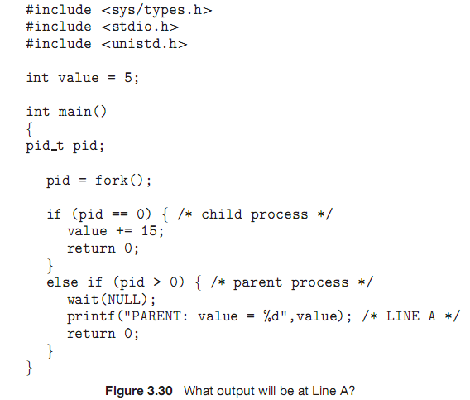

Output at Line A will be : “PARENT: value = 20”

3.2 Including the initial parent process, how many processes are created by the program shown in Figure 3.31?

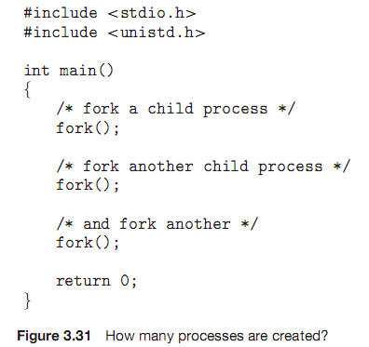

8 processes are created

3.3 Original versions of Apple’s mobile iOS operating system provided no means of concurrent processing. Discuss three major complications that concurrent processing adds to an operating system.

3.4 The Sun UltraSPARC processor has multiple register sets. Describe what happens when a context switch occurs if the new context is already loaded into one of the register sets. What happens if the new context is in memory rather than in a register set and all the register sets are in use?

3.5 When a process creates a newprocess using the fork() operation,which of the following states is shared between the parent process and the child process?

a. Stack

b. Heap

c. Shared memory segments

3.6 Consider the “exactly once”semanticwith respect to the RPCmechanism. Does the algorithm for implementing this semantic execute correctly even if the ACK message sent back to the client is lost due to a network problem? Describe the sequence of messages, and discuss whether

“exactly once” is still preserved.

3.7 Assume that a distributed system is susceptible to server failure. What mechanismswould be required to guarantee the “exactly once” semantic for execution of RPCs?

**Exercises**

3.8 Describe the differences among short-term, medium-term, and long-term scheduling.

3.9 Describe the actions taken by a kernel to context-switch between processes.

3.10 Construct a process tree similar to Figure 3.8. To obtain process information for the UNIX or Linux system, use the command ps -ael.

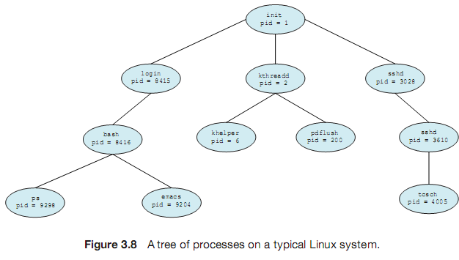

Use the command man ps to get more information about the ps com-mand. The task manager on Windows systems does not provide the parent process ID,butthe process monitor tool, available from tech-net.microsoft.com, provides a process-tree tool.

3.11 Explain the role of the init process onUNIX and Linux systems in regard to process termination.

3.12 Including the initial parent process, how many processes are created by the program shown in Figure 3.32?

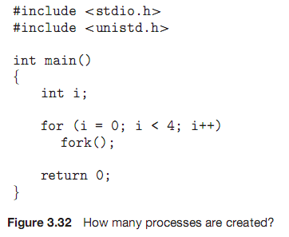

3.13 Explain the circumstances under which which the line of code marked printf("LINE J") in Figure 3.33 will be reached.

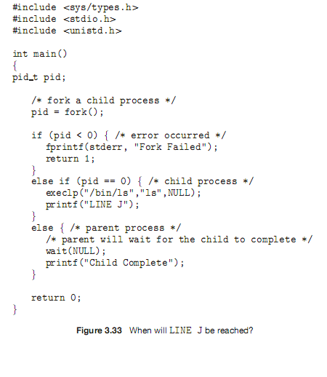

3.14 Using the programin Figure 3.34, identify the values of pid at lines A, B, C,and D. (Assume that the actual pids of the parent and child are 2600 and 2603, respectively.)

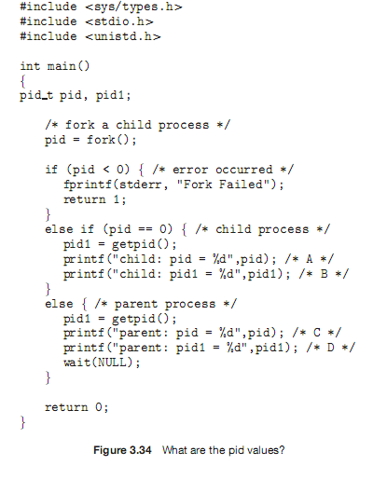

3.15 Give an example of a situation inwhich ordinary pipes aremore suitable than named pipes and an example of a situation in which named pipes are more suitable than ordinary pipes.

3.16 Consider the RPC mechanism. Describe the undesirable consequences that could arise from not enforcing either the “at most once” or “exactly once” semantic. Describe possible uses for amechanism that has neither of these guarantees.

3.17 Using the program shown in Figure 3.35, explain what the output will be at lines X and Y.

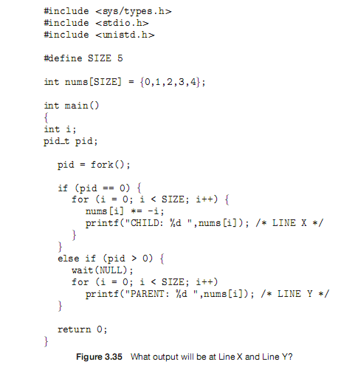

3.18 What are the beneﬁts and the disadvantages of each of the following? Consider both the system level and the programmer level.

a. Synchronous and asynchronous communication

b. Automatic and explicit buffering

c. Send by copy and send by reference

d. Fixed-sized and variable-sized messages